Dehydrated
Banana Chips

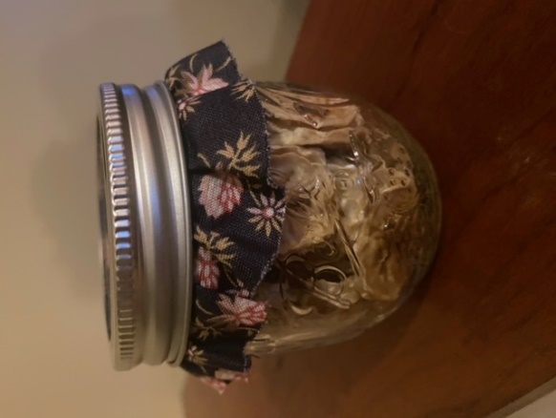

Reagan Mittelstadt
Years in Project: 5
Grade: 8

My Goal:
To create a healthier snack option of dehydrated bananas instead of buying them from the store with additives. Dehydrating bananas can also save money and food waste if you have bananas that may be going bad. Whether you are looking to eat healthier snacks or save money, these are great snacks!

Time:
Prep Time – 10 minutes
Dehydration Time – 12 hours
Total Time – 12 hours, 10 minutes

Yield:
This is customizable each time you dehydrate. You can fill your dehydrator trays, or you can dehydrate just the bananas you have on-hand before they go bad from over ripening. For this batch, I dehydrated 4 bananas and filled two trays in my dehydrator at 135 degrees Fahrenheit for 12 hours.

How to Store:
You must store your cooled dehydrated bananas in an airtight container or bag. This will keep them dry and avoid them picking up moisture in the air which could cause spoilage. It is best to also keep the container of dehydrated bananas in a dark cabinet and out of direct sunlight.

What I Learned:
Dehydrating bananas is fun, easy to do, makes a healthy snack and saves on food waste.

Results:
A pint size jar of yummy banana chips in a dehydrated form without any artificial flavors or additives. These can be taken on road trips, sporting events, in your lunch, or to add an extra kick to banana bread.

Cost Comparison:
Homemade
The cost for all ingredients to make at home would be $1.18. The bananas were $.59 per pound and they were my only ingredient. I did not include the cost of the dehydrator as I used my family dehydrator and re-used an old jam jar.
In Store
I found the Bare brand of banana chips in Wal-Mart for $4.97 for a 2.7 ounce bag.
Bare Fruit - Crunchy Banana Chhttps://www.ohnuts.com/buy.cfm/bulk-dried-fruits/bananas-2/banana-chips-unsweetened?pre=41230&utm_source=bing&utm_medium=cpc&utm_campaign=ECI%20-%20Bing%20Shopping%20All%20Products%20%5BCONS%5D&utm_term=1101012479291&utm_content=All%20Products%20Bing%20Bulk%20Dried%20Fruitips Simply Baked, 2.7 oz Bag, Packaging May Vary - Walmart.com

I found another variety of banana chips on Oh Nuts! In a 1 pound bag for $4.69. This is a website and would also require shipping.
Banana Chips - Unsweetened • Dried Bananas • Bulk Driedhttps://www.ohnuts.com/buy.cfm/bulk-dried-fruits/bananas-2/banana-chips-unsweetened?pre=41230&utm_source=bing&utm_medium=cpc&utm_campaign=ECI%20-%20Bing%20Shopping%20All%20Products%20%5BCONS%5D&utm_term=1101012479291&utm_content=All%20Products%20Bing%20Bulk%20Dried%20Fruit Fruits • Oh! Nuts® (ohnuts.com)

In comparison, my banana chips are less costly than store bought and avoid the risk of artificial flavors or additives.

Nutrition Facts:
The Department of Agriculture My Plate suggests we eat fewer empty calories which are treats and sweet beverages. Sugar and fats are sources of empty calories that do not provide energy for the body. To eat a healthy diet it is best to have treats in small amount and not every day. A treat should be a treat that is not a major food source, to be enjoyed less often. The good thing is my treat is a natural fruit.
The biggest source of empty calories in my bananas would be the natural sugar at 18.4 grams.
The biggest positive source with these being a natural fruit is the vitamin content. The banana chips have 537 milligrams of Potassium each serving and 8 milligrams of Calcium each serving. Another key item to being a healthy treat is Dietary Fiber is 3.9 grams which is 14% of our daily value needed of fiber. The banana chips also have 1.6 grams of Protein and only 0.5 grams of Total Fat.

I was able to use the nutrition calculator on verwellfit.com for my banana chips.
Dehydrated Banana Chip Recipe:

Ingredients:
4 bananas cut into slices, approximately 3/8 inch

Place banana slices on dehydrator trays without touching for air circulation. Put the dehydrator on 135 degrees Fahrenheit for 10-12 hours. Store cooled chips in an airtight container or bag for up to 2 months. Keep the chips out of direct sunlight.

Yield: Quart size bag or jelly jar.

